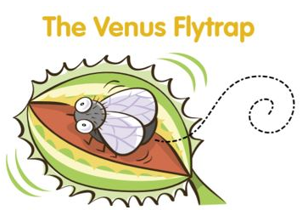

If a ﬂy lands on one of the leaves of a Venus flytrap, the leaves snap shut and suddenly it’s trapped! The Venus ﬂytrap is a carnivorous plant, which means it eats living things. Its leaves have tiny hairs that act like motion detectors. When an insect touches the hairs, it triggers the leaves to quickly snap shut, trapping and killing the insect. The leaves squeeze the insect tightly, and slowly the plant digests all the nutrients. About a week later, the leaves reopen and the skeleton of the insect falls out. The Venus ﬂytrap gets ready for its next meal!

1. Are these statements true or false?

|  |  |  |
| --- | --- | --- |
|  | True | False |
| If a fly lands on the flower of a Venus flytrap, it becomes trapped. | X | ✓ |
| The leaves squeeze the insect gently. | X | ✓ |
| After about a week, the skeleton of the insect falls out of the leaf. | ✓ | X |

2. Find and copy a word that means…

a. eats living things ___ carnivorous _____

b. very small _____tiny________________________

c. open again _____reopen__________________

3. Put these statements in order.

d.A ﬂy lands on one of the leaves of a Venus flytrap.

c.The insect touches the hairs of the leaf making it snap shut.

b The leaves squeeze the insect tightly.

a.The leaves reopen and the skeleton of the insect falls out.