**Reading Tuesday 23rd June**

Sergeant Smith has set up the outpost near the hydrogen fields and Lieutenant Khan has set off to take more supplies to her.

Along the way, she met a creature that called itself a Munctious Aloom. It looked very scary but, perhaps because Lt Khan had a weapon, it caused no problem. After the encounter, the creature raced off in the direction of the hydrogen deposits.

**Your task:** The UFP has requested **a labelled drawing** of the unusual creature for its records of the planet, based on the description below. . Don’t forget to label the drawing – this is vital.

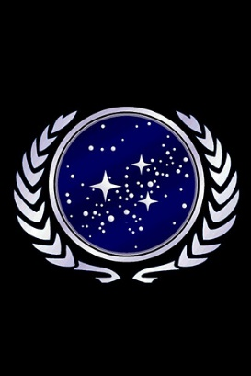

UFP

Report from Lieutenant Khan

*As requested, here is my description of the creature I met on my way to take supplies to Sergeant Smith at the hydrogen deposit outpost:*

*The creature jumped down from a high branch in a tree and snarled viciously until it noticed my weapon. It introduced itself as a Munctious Aloom. The beast was short and round, but had enormous eyes that perched, unblinking, on top of its bald head. This looked particularly strange because the rest of its body, round and wobbly, was covered in thick, brown hair. From its wide open mouth, slimy green drool dripped down onto its large belly and onwards to the ground, where it pooled disgustingly near its four tentacle-like feet. Two rows of razor-sharp knife-like teeth grinned dangerously at me before it raced off in the direction of the hydrogen fields.*